DATABASE MANAGEMENT LAB
LAB Report
Submitted in partial fulfilment of the requirement of the degree of
BACHELORS OF TECHNOLOGY
to
K.R Mangalam University



Submitted by: Submitted to
Vansh Tanwar Ms. Mansi Kajal
(2401010102)

Department of Computer Science and Engineering School of Engineering and Technology
K.R Mangalam University, Gurugram- 122001, India SESSION – 2025-2026

Lab Sheet: 1

PART A – COLLEGE DATABASE
STUDENT ( USN, SName, Address, Phone, Gender ) SEMSEC ( SSID, Sem, Sec )

CLASS ( USN, SSID )
SUBJECT ( Subcode, Title, Sem, Credits )
IAMARKS ( USN, Subcode, SSID, Test1, Test2, Test3, FinalIA )
Solution:
- The entities STUDENT, SEMSEC, SUBJECT, and IAMARKS are identified and represented using rectangles.
- The attributes are represented using ellipses:
- STUDENT: USN (Primary Key), SName, Address, Phone, Gender
- USN is underlined as it is the Primary Key.
- Phone is shown as a single-valued attribute.
- SEMSEC: SSID (Primary Key), Sem, Sec
- SSID is underlined as the Primary Key.
- SUBJECT: Subcode (Primary Key), Title, Sem, Credits
- Subcode is underlined as the Primary Key.
- IAMARKS: USN, Subcode, SSID, Test1, Test2, Test3, FinalIA
- USN, Subcode, and SSID together form a composite key.
- Test1, Test2, Test3, and FinalIA are normal attributes.
- Primary keys are represented by underlining the attribute names.
- CLASS is drawn as a relationship (diamond shape) between STUDENT and SEMSEC.
- The relationship between STUDENT and SEMSEC through CLASS is M : 1, meaning many students belong to one semester and section.
- The M : N relationship between STUDENT and SUBJECT is resolved using the associative entity IAMARKS.
- The relationship STUDENT – IAMARKS is 1 : M, indicating one student can have multiple internal assessment records.
- The relationship SUBJECT – IAMARKS is 1 : M, indicating one subject can have multiple IA records for different students.
- The relationship SEMSEC – IAMARKS is 1 : M, showing that marks are maintained semester- section wise.

- All entities, attributes, relationships, primary keys, foreign keys, and cardinalities are clearly represented in the ER diagram.

ER DIAGRAM:
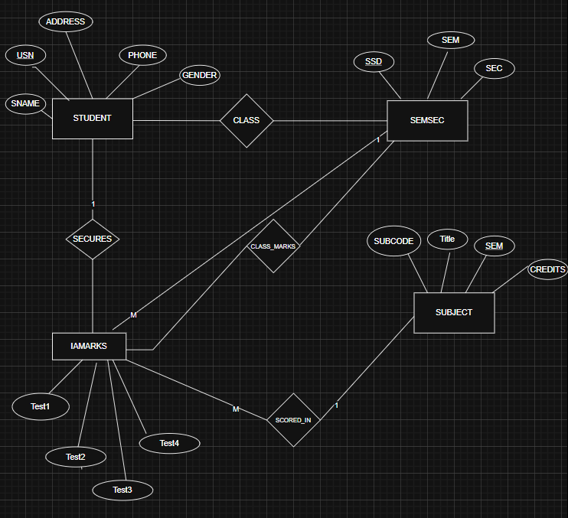

PART B – COMPANY DATABASE
EMPLOYEE ( SSN, Name, Address, Sex, Salary, Superssn, Dno ) DEPARTMENT ( Dno, Dname, Mgrssn, Mgrstartdate ) DLOCATION ( Dno, Dloc )
PROJECT ( PNo, PName, PLocation, DNo ) WORKS_ON ( SSN, PNo, Hours )
Solution:
- The entities EMPLOYEE, DEPARTMENT, PROJECT, and DLOCATION are identified and represented using rectangles.
- The attributes are represented using ellipses:
- EMPLOYEE: SSN (Primary Key), Name, Address, Salary, Sex, SuperSSN, DNO
- SSN is underlined as it is the Primary Key.
- SuperSSN is a foreign key referencing EMPLOYEE (self-relationship).
- DNO is a foreign key referencing DEPARTMENT.
- DEPARTMENT: DNo (Primary Key), DName, MgrSSN, MgrStartDate
- DNo is underlined as the Primary Key.
- MgrSSN is a foreign key referencing EMPLOYEE.

- PROJECT: PNo (Primary Key), PName, PLocation, DNO
- PNo is underlined as the Primary Key.
- DNO is a foreign key referencing DEPARTMENT.
- DLOCATION: DNo, DLoc
- DNo and DLoc together form a composite key.
- DNo is a foreign key referencing DEPARTMENT.
- WORKS_ON: SSN, PNo, Hours
- SSN and PNo together form a composite key.
- Hours is a descriptive attribute of the relationship.
- Primary keys are represented by underlining the attribute names.
- The relationship WORKS_ON is drawn as a diamond between EMPLOYEE and PROJECT with
M : N cardinality, indicating that:
  - One employee can work on many projects.
  - One project can have many employees.
  - Hours attribute represents the number of hours worked.
- The relationship MANAGES is drawn between EMPLOYEE and DEPARTMENT with 1 : 1 cardinality, indicating:
  - One employee manages one department.
  - Each department has one manager.
- The relationship between EMPLOYEE and DEPARTMENT (via DNO) is M : 1, meaning:
  - Many employees work in one department.
- The relationship between DEPARTMENT and PROJECT is 1 : M, meaning:
  - One department controls many projects.
  - Each project belongs to one department.
- The relationship between DEPARTMENT and DLOCATION is 1 : M, meaning:
  - One department can have multiple locations.
- A recursive relationship exists in EMPLOYEE through SuperSSN, representing that:
  - One employee can supervise many employees.
- All entities, attributes, relationships, primary keys, foreign keys, and cardinalities are clearly represented in the ER diagram.

ER DIAGRAM:
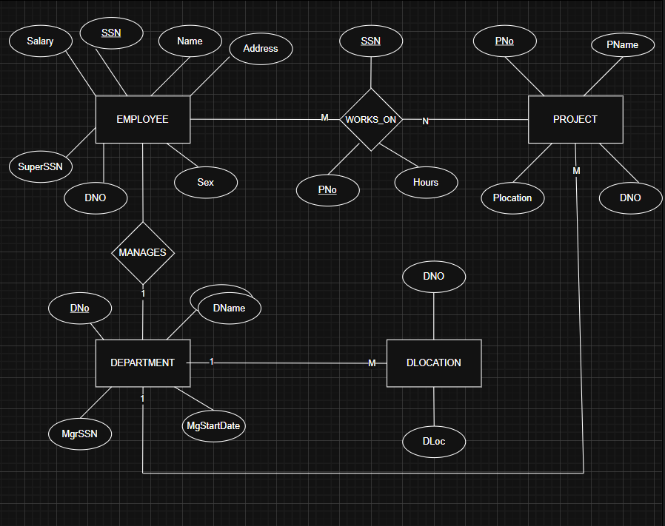

PART C – CUSTOMER SALE SCHEMA
Database Schema for a customer-sale scenario Customer(Cust id : integer, cust_name: string)
Item(item_id: integer, item_name:string, price: integer)
Sale(bill_no:integer,bill_data:date,cust_id: integer, item_id: integer, qty_sold: integer)
Solution:
Entities and Attributes
- CUSTOMER Entity
The CUSTOMER entity stores information about customers who purchase products. Attributes:
  - Cust_ID – Unique identification number of a customer (Primary Key)
  - Cust_Name – Name of the customer
Each customer is uniquely identified using Cust_ID.
- SALE Entity
The SALE entity represents transaction or billing information whenever a customer buys items. Attributes:
  - Bill_No – Unique bill number (Primary Key)

  - Bill_Date – Date on which purchase is made
  - Qty_Sold – Quantity of items purchased
This entity acts as a bridge between customer and item details.
- ITEM Entity
The ITEM entity contains details about products available for sale. Attributes:
  - Item_ID – Unique product identification number (Primary Key)
  - Item_Name – Name of the item
  - Price – Cost of the item
Each item is uniquely identified by Item_ID. Relationships
- MAKES Relationship
This relationship connects CUSTOMER and SALE.
  - A Customer can make many sales.
  - Each Sale belongs to only one customer. Cardinality:
CUSTOMER (1) -------- MAKES (M) SALE
Meaning:
One customer may generate multiple bills.
- INCLUDES Relationship
This relationship connects SALE and ITEM.
  - One Sale may include multiple items.
  - Each Item can appear in many sales. Cardinality:
SALE (M) -------- INCLUDES (1) ITEM
Meaning:
A bill contains purchased items. Key Concepts Used
  - Entities represent real-world objects.
  - Attributes describe entity properties.

  - Primary Keys uniquely identify records.
  - Relationships show interaction between entities.
  - Cardinality defines how many entities participate in a relationship. Relational Schema Derived
From the ER diagram, the following relational tables are obtained: CUSTOMER (Cust_ID, Cust_Name)
ITEM (Item_ID, Item_Name, Price)

SALE (Bill_No, Bill_Date, Cust_ID, Item_ID, Qty_Sold) Where:
  - Cust_ID is a Foreign Key referencing CUSTOMER.
  - Item_ID is a Foreign Key referencing ITEM.

ER DIAGRAM:
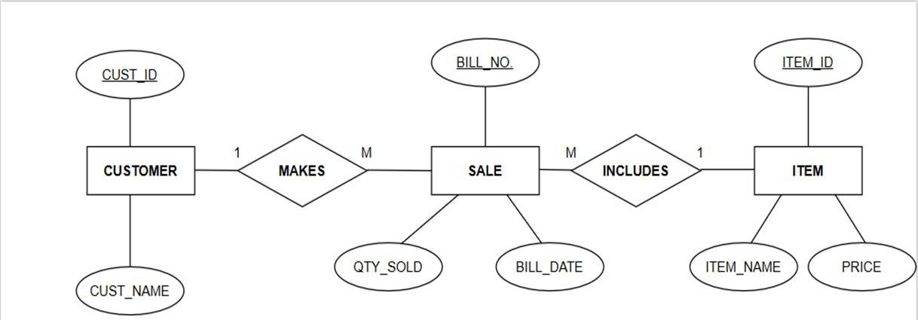

DDL Questions (Data Definition Language):
- Write SQL statements to create all the above relations with appropriate PRIMARY KEY and FOREIGN KEY constraints.
STEP 1: CREATE DATABASE
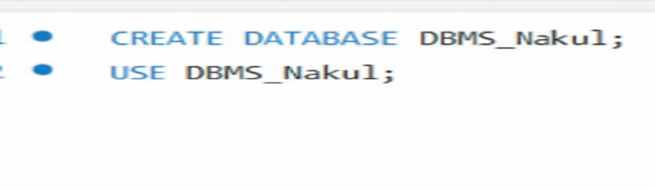
PART A – COLLEGE DATABASE :
1. CREATE TABLES

- STUDENT TABLE :
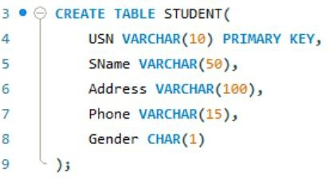
- SEMSEC TABLE :
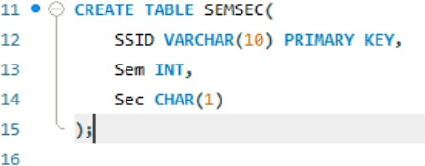
- CLASS TABLE:
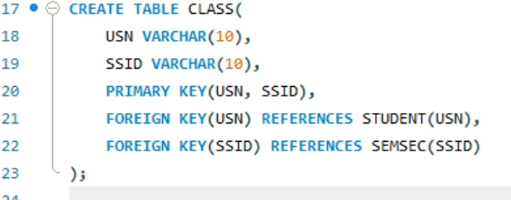
- SUBJECT TABLE :
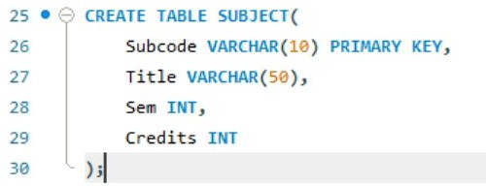
- IMARKS TABLE :
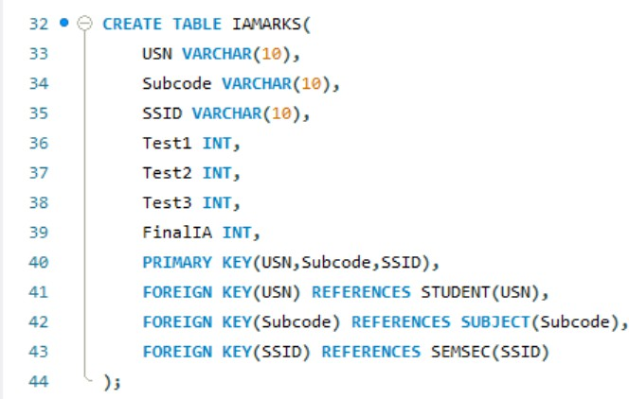

PART B – COMPANY DATABASE : (i)DEPARTMENT TABLE :
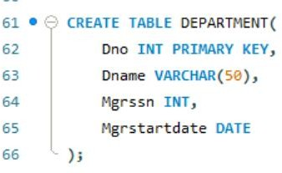
- EMPLOYEE TABLE :
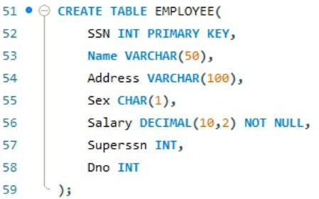
- DLOCATION TABLE :
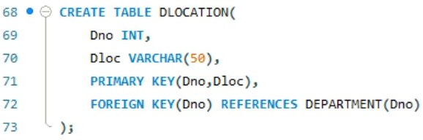
- PROJECT TABLE :
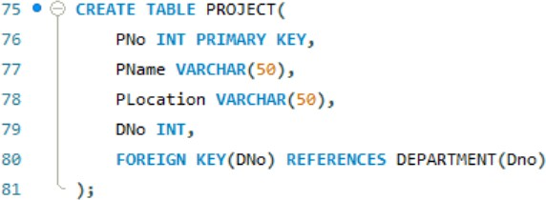

- WORKS_ON TABLE :
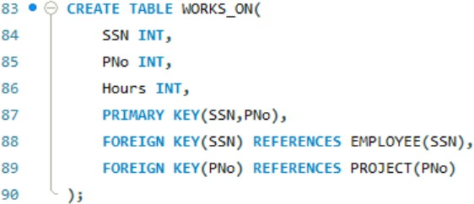

PART C – CUSTOMER SALE SCHEMA:
- CUSTOMER TABLE:
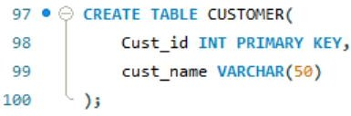
- ITEM TABLE:
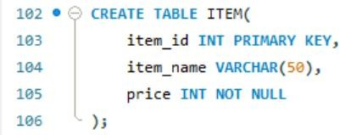
- SALE TABLE :
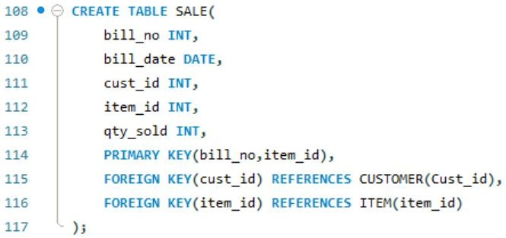
- Add a new column Email to the STUDENT relation.
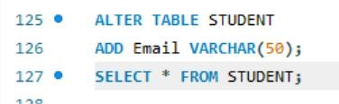
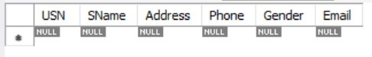

- Apply NOT NULL constraints to Salary and Price attributes.
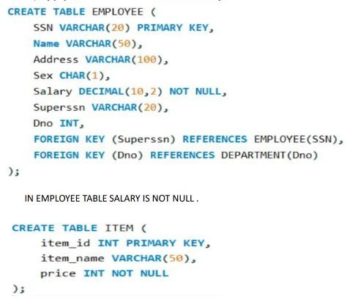

- Rename attribute SName to StudentName in STUDENT relation.
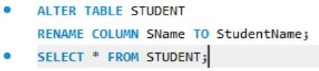
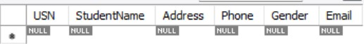

- Drop the DLOCATION relation.
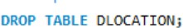

DML Questions (Data Manipulation Language):
Question : Database Schema for a customer-sale scenario Customer(Cust id : integer, cust_name: string)
Item(item_id: integer, item_name: string, price: integer)
Sale(bill_no:integer,bill_data:date,cust_id: integer, item_id: integer, qty_sold: integer) For the above schema, perform the following—
- Create the tables with the appropriate integrity constraints.
Output:
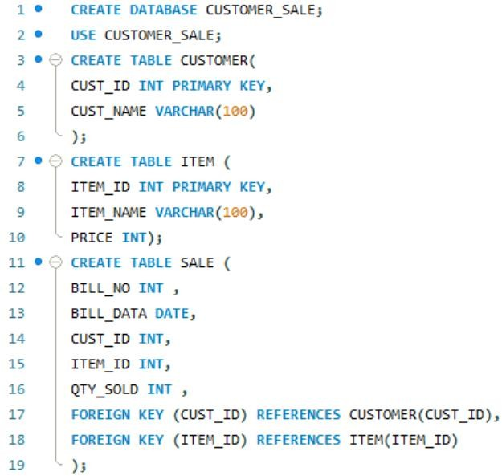

- Insert around 10 records in each of the tables.

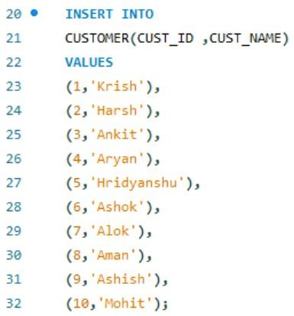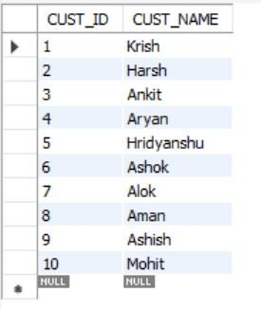

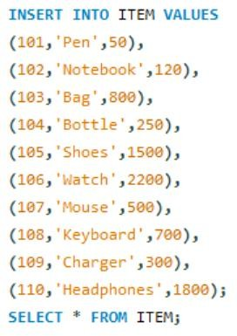
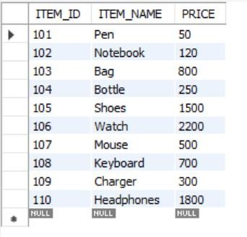
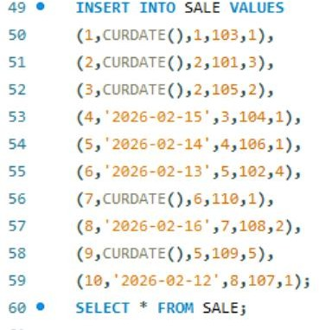
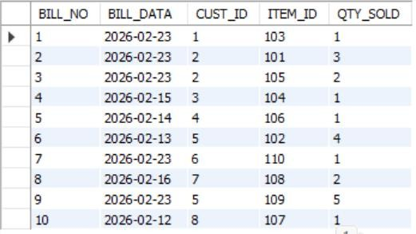

- List all the bills for the current date with the customer names and item numbers

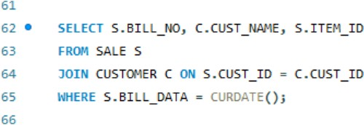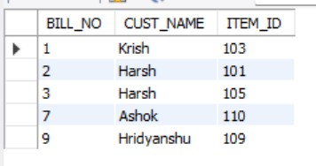
- List the total Bill details with the quantity sold, price of the item and the final amount.
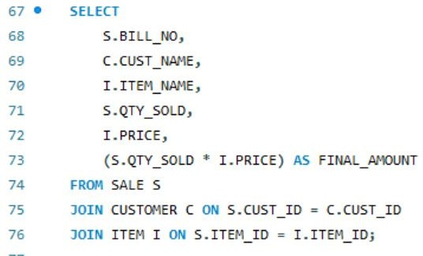
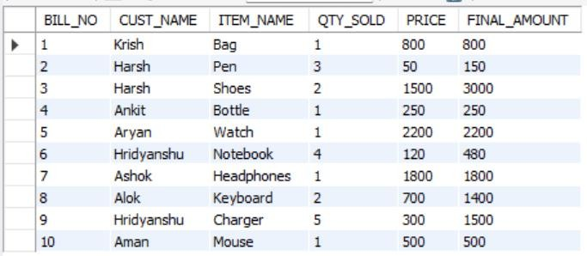
- List the details of the customer who have bought a product which has a price>200
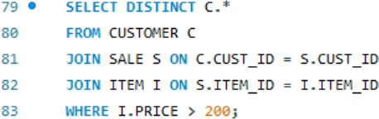
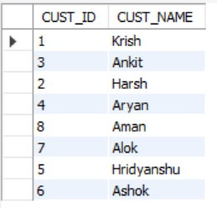
- Give a count of how many products have been bought by each customer
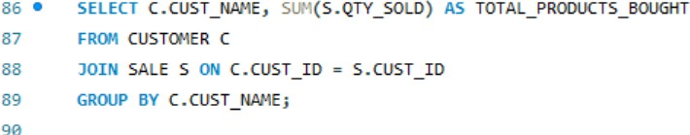
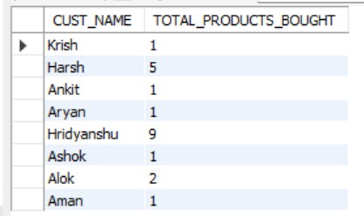

- Give a list of products bought by a customer having cust_id as 5.
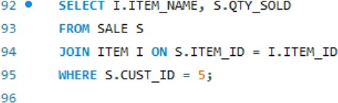
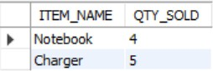

- List the item details which are sold as of today.
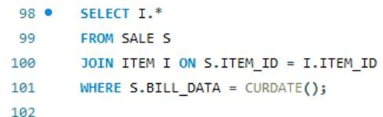
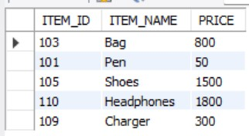
- Create a view which lists out the bill_no, bill_date, cust_id, item_id, price, qty_sold,Amount
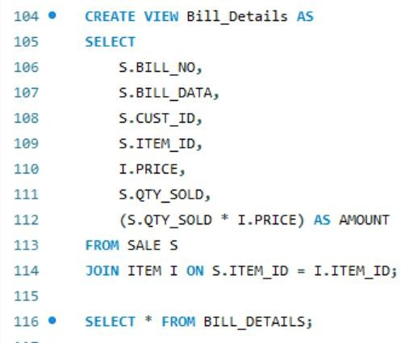
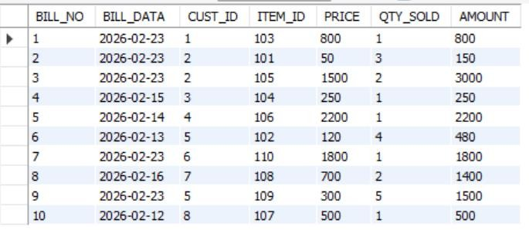

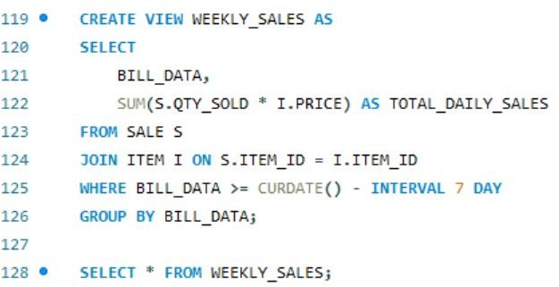
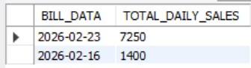
- Create a view which lists the daily sales date wise for the last one week

